附件2：
第二届全国高职高专英语写作大赛
公共英语组赛区选拔赛样题
The 2nd National English Writing Contest
For Vocational College Students
（Semifinal）
（两部分，100分，120分钟，共1页）

Part I (40 points)
Directions: Write a MEMO based on the following information. Write more than 100 words.
Suppose that you are Kevin Green, the general manager of CSW Electric Co. You will write a memo to David Smith, the manager of the R&D Department. The memo should cover the following issues:
1) The sales of our TV sets have decreased greatly in the first two quarters of this year.
2) In order to maintain our market share, we have to develop new products.
3) You (David Smith) should prepare a development report to be discussed in the next board meeting.

Part II (60 points)
Directions: Write a report based on the following information. Write more than 350 words.
The line chart shows the number of vehicles sold in the U.S and China markets from 1980 to 2008. Analyze the chart and offer reasons for your conclusions.

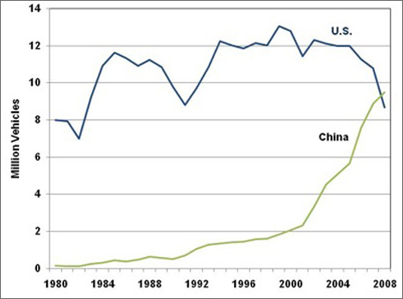
第二届全国高职高专英语写作大赛
英语专业组赛区选拔赛样题
The 2nd National English Writing Contest
For Vocational College Students
（Semifinal）
（两部分，100分，120分钟，共1页）

Part I (40 points)
Directions: Apton Electonis Co. is a manufacturer of electronic dictionaries for college students. Now it has developed a new model and is going to start a promotion on campuses. Please draft a short advertisement for it. Write more than 200 words.

  Model: ELX 3800 | Specifications:  - English and Chinese dictionaries for business, travel, and language study  - With 45,000 entries and 55,000 examples  - Real voice pronunciation  - Google search for words and titles  - Four colours to choose from: black/blue/pink/silver  - 32-bit MCU  - USB interface for downloading and charging through connected computer  - Built-in memory: 4GB  - Hi-fi MP3/MP4  - 3.2-inch TFT color screen, clear display

Part II (60 points)
Directions: Write a proposal based on the following information. Write more than 350 words.
Suppose you are working for the Marketing Department of HPA Company. Your department is collecting proposals on possible cuts to promotion budgets next year. Please write a proposal explaining why some cuts have to be made and how they can be made.

